First visual record of Caesio cf. teres Seale, 1906 (Perciformes: Caesionidae) in the Mediterranean
Servet Ahmet Doğdu ^{1,2,*} , Mahmut İğde ¹, Necdet Uyğur ¹, Cemal Turan²
¹ Iskenderun Technical University, Maritime Technology Vocational School of Higher Education, Underwater Technologies, 31200 Iskenderun, Hatay, Türkiye.
² Iskenderun Technical University, Faculty of Marine Sciences and Technology, Molecular Ecology and Fisheries Genetics Laboratory, 31220, Iskenderun, Hatay, Türkiye.
Corresponding Author: servet.dogdu@iste.edu.tr
Abstract
On 20 May 2025, an individual belonging to the genus Caesio was recorded by underwater video at Yayladağ coast in the Mediterranean. The species observed with the underwater camera appears to be morphologically similar to Caesio teres. However, due to the lack of a physical specimen, a definitive species identification could not be made. This is the first known visual record of the Caesio teres species in the Mediterranean basin. It is believed that the species recently arrived in the Mediterranean via the Lessepsian migration route through the Suez Canal. The observation of a single individual in the region and the inability to obtain a physical fish specimen highlight the important role of video or photograph-based observations in the early detection of alien species.
Keywords
Caesionidae, Lessepsian migration, Iskenderun Bay, Caesio teres
Introduction
Climate change and the opening of the Suez Canal have facilitated the passage of alien species into the Mediterranean. This is causing changes in Mediterranean biodiversity (Turan et al., 2016; Langeneck et al., 2023; Deidun et al., 2024; Doğdu and Turan, 2024; Sliskovic et al., 2024; Zenetos et al., 2024; Golani, 2025). The combination of these two important factors has led to more than 100 exotic fish species entering the Mediterranean to date (Galil et al., 2018; Turan et al., 2018; Khalil et al., 2025).
The Caesionidae, commonly known as fusiliers, are distributed throughout the Indian and Pacific Oceans and comprise four genera and 24 species (Nelson, 2006; Bariche and Fricke, 2018; Froese and Pauly, 2025). They have a long fusiform body, a deep forked caudal fin, and a small mouth with a protruding upper jaw, which are important morphological characteristics (Bariche and Fricke, 2018). Members of this family are usually found near coral reefs, feed on zooplankton, and range from the surface to depths of 60 meters (Froese and Pauly, 2025).
The first member of the Caesionidae family reported from the Mediterranean coast is the species Dipterygonotus balteatus, reported from the coast of Lebanon (Bariche and Fricke, 2018). Subsequently, the presence of another fusilier, Caesio varilineata, has been reported from the coast of Egypt (Bos and Ogwang, 2018).
In this study, we report the first record of the yellow and blueback fusilier Caesio cf. teres Seale, 1906 in the Mediterranean and supported by documented in situ underwater photographs.
Material and Methods
Caesio cf. teres was observed on May 20, 2025, off the coast of Yayladağ (35.957757 N, 35.927183 E) at a depth of 12 meters and a water temperature of 24°C, as recorded by a dive computer. The fusilier specimen was documented in situ using a GoPro HERO 10 with underwater housing and external video lighting for photography and videography. Multiple photographs and videos were taken from different angles to capture key morphological features.
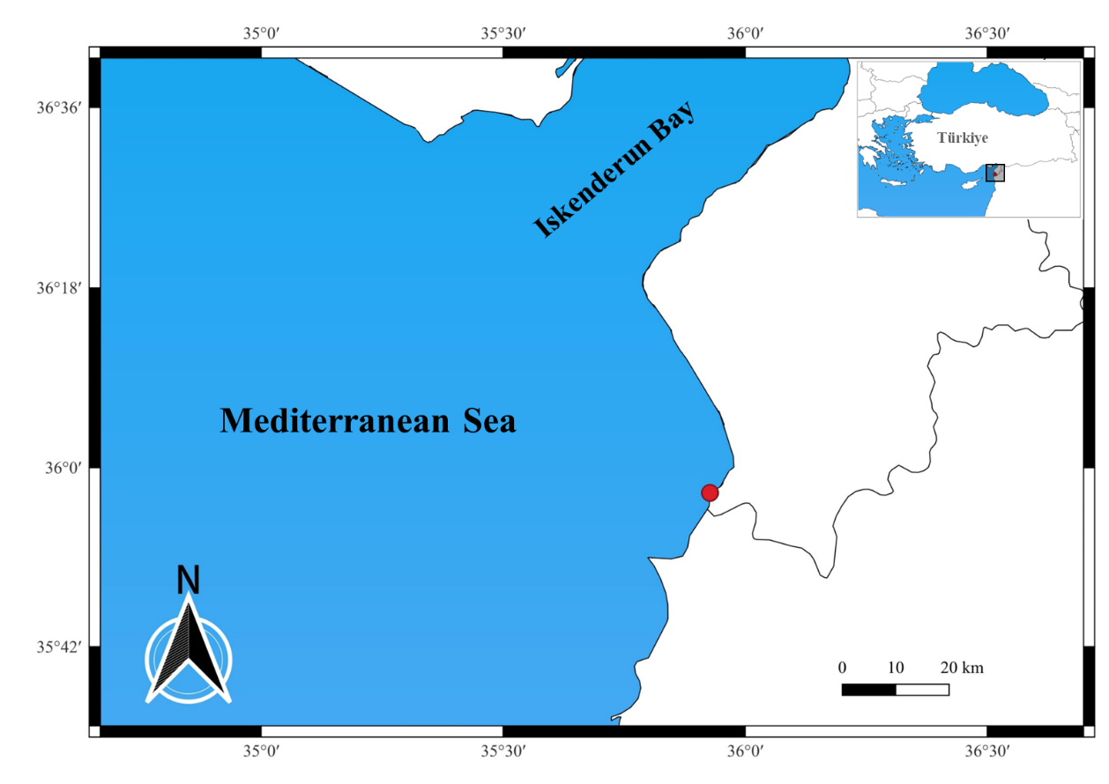
Figure 1. Visual observation site of Caesio cf. teres in the Mediterranean.
Morphological identification was carried out by comparing the observed features with published descriptions and identification keys for Caesio teres and other Caesionidae members (Carpenter, 1988; Nelson, 2006; Allen and Erdmann, 2012; Bariche and Fricke, 2018). The diagnostic features considered are: fusiform body shape, distinct yellow back color and bluish sides, deeply forked tail fin, small, protruding mouth with upper jaw extending beyond the eye line. The abbreviation “cf.” was used to indicate that the recorded specimen closely resembles Caesio teres based on its observable morphology, but cannot be fully confirmed because genetic and other measurable morphological analyses could not be performed on the specimen.
Results and Discussions
The number of alien species in Turkish waters has been increasing rapidly in recent years (Langeneck et al., 2023; Turan et al., 2024). The increasing number of alien species is affecting food webs, leading to significant changes in Mediterranean biodiversity (Arndt et al., 2018; Turan et al., 2024). In this study, we report the first visual record of the Yellow and blueback fusilier, Caesio cf. teres, a new alien fish species in the Mediterranean.
Caesio teres is distinguished by its fusiform body, deeply forked tail fin, and small, protruding mouth. The sides of the body are blue, while the belly is whitish. This species is characterized by a bright yellow dorsal surface extending from the nape to the tail stalk and a completely yellow tail fin. (Carpenter and Allen, 1989; Nelson, 2006; Bariche and Fricke, 2018; Froese and Pauly, 2025). The detected specimen has a moderately deep, fusiform, and compressed body. Based on the visual descriptions in the photos and videos, the caudal fin, caudal, and dorsal fins are bright yellow along a diagonal line from the start of the dorsal fin to the beginning of the caudal peduncle. The upper body is bright blue, while the lower abdominal area is silvery white. The base of the pectoral fin is black, the pectoral, pelvic, and anal fins are white, and the front part of the dorsal fin is bluish, transitioning to yellow at the rear (Figure 2).
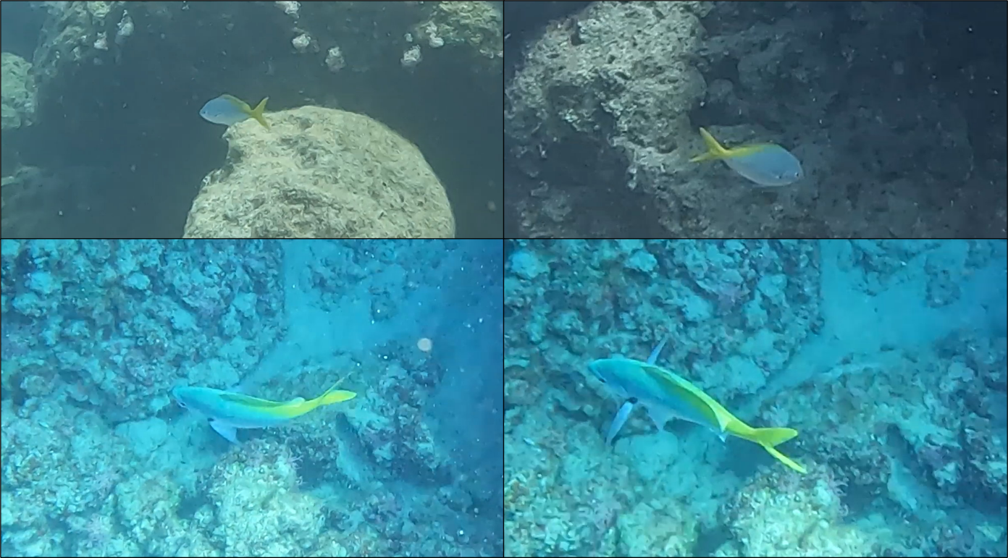
Figure 2. Different views of Caesio cf. teres observed at a depth of 12 meters off the coast of Yayladağ on May 20, 2025 (The video is available at: https://youtu.be/5EA8GP-Ctug).
A few species within the Caesionidae family that can be confused with Caesio cf. teres in terms of external appearance as C. cuning, C. caerulaurea, and C. xanthonota. In terms of external appearance, C. teres differs from C. cuning in both body shape and colouration. C. teres has a slenderer body structure, while C. cuning has a distinctly stouter body. In terms of colouration, C. teres has a broad yellow area along the back and a yellow tail, while C. cuning has a grey-blue or greenish back, a white-pinkish belly, and only the tail fin is yellow. The yellow colouration along the back observed in C. teres is absent in C. cuning. Therefore, external morphology and colour patterns allow the two species to be reliably distinguished (Carpenter and Allen, 1989; Bariche and Fricke, 2018).
C. teres is often mistaken for C. caerulaurea, but they have distinct features. C. caerulaurea is identified by a single, narrow yellow stripe running along its side and prominent black bands on both lobes of its caudal fin. In contrast, C. teres lacks the yellow stripe and black markings, instead displaying a broad yellow area on the dorsal part of its body and a completely yellow tail. These color pattern differences make it easy to distinguish C. teres from C. caerulaurea. (Carpenter and Allen, 1989; Allen and Erdmann, 2012).
C. teres also resembles C. xanthonota in overall body form. Externally, C. xanthonota displays a yellow dorsal region and a bluish to whitish underside, but it is readily distinguished by the presence of black-tipped caudal lobes. In contrast, C. teres has an entirely yellow caudal fin without black tips. Thus, although both species share a yellow dorsal region, the caudal fin colouration clearly separates C. teres from C. xanthonota (Allen and Erdmann, 2012; Bariche and Fricke, 2018).
In conclusion, our study documents the first record of the yellow- and blue-backed fusilier Caesio cf. teres from the Mediterranean, supported by underwater photographs and videos taken in situ. Although this species bears superficial similarities to its close relatives such as C. cuning, C. caerulaurea, and C. xanthonota, its external morphological characteristics and color patterns allow for reliable differentiation. Additionally, it demonstrates the significant role of in situ underwater observations in the early detection of alien species arriving via migration routes.
Acknowledgements
This study was supported by the Scientific and Technological Research Council of Türkiye (TUBITAK) under Grant Number 223O555. The authors thank TUBITAK for their support.

Conflict of Interest
The authors declare no competing interests.
Ethics Committee Approval
Local Ethics Committee Approval is not required as experimental animals were not used in this study.
Referances
Allen, G. R., and Erdmann, M. V. (2012). Reef Fishes of the East Indies. Volumes I–III. Tropical Reef Research, Perth, Australia. 1292 pp.
Arndt, E., Givan, O., Edelist, D., Sonin, O., and Belmaker, J. (2018). Shifts in eastern Mediterranean fish communities: Abundance changes, trait overlap, and possible competition between native and non-native species. Fishes, 3(2), 19.
Bariche, M., and Fricke, R. (2018). Dipterygonotus balteatus (Valenciennes, 1830) and Caesio varilineata Carpenter, 1987, new alien fish in the Mediterranean Sea. BioInvasions Records, 7(2): 149–153.
Bos, A. R., and Ogwang, J. (2018). First record of Caesio varilineata (Perciformes: Caesionidae) from the Mediterranean coast of Egypt. Marine Biodiversity Records, 11(1): 1–4.
Carpenter, K.E., (1988). FAO species catalogue. Vol 8. Fusilier fishes of the world. An annotated and illustrated catalogue of Caesionid species known to date. FAO Fish.Synop., (125) Vol.8:75 p.
Deidun, A., Corsini-Foka, M., Marrone, A., Galdies, J., Zava, B., Crobe, V., and Tinti, F. (2024). Yet another non-indigenous fish from Maltese waters, central Mediterranean: a first record of Lagocephalus guentheri Miranda Ribeiro, 1915 (Tetraodontiformes, Tetraodontidae). BioInvasions Records, 13(3), 777–786.
Doğdu, S. A., and Turan, C. (2024). Biological and growth parameters of Plotosus lineatus in the Mediterranean Sea. PeerJ, 12, e16945.
Froese, R., and Pauly, D. (eds.). (2025). FishBase. World Wide Web electronic publication. Available at: www.fishbase.org.
Galil, B. S., Marchini, A., and Occhipinti-Ambrogi, A. (2018). Mare Nostrum, mare quod invaditur the history of bioinvasions in the Mediterranean Sea. Histories of Bioinvasions in the Mediterranean, 21-49.
Golani, D. (2025). Update of Red Sea (Lessepsian) fish species in the Mediterranean Sea since the 2nd CIESM Atlas of Exotic Fish. Mediterranean Marine Science, 26(1), 149-155.
Khalil, M. T., Mostafa, A. B., and El-Naggar, M. M. (2025). Climate Change and Lessepsian Migration to the Mediterranean Sea. In: Climate Changes Impacts on Aquatic Environment: Assessment, Adaptation, Mitigation, and Road Map for Sustainable Development (pp. 85-118). Cham: Springer Nature Switzerland.
Langeneck, J., Bakiu, R., Chalari, N., Chatzigeorgiou, G., Crocetta, F., Doğdu, S. A., ... and Zenetos, A. (2023). New records of introduced species in the Mediterranean Sea (November 2023). Mediterranean Marine Science, 24(3), 610-632.
Nelson, J. S. (2006). Fishes of the World (4th ed.). John Wiley and Sons, Hoboken, NJ, USA. 601 pp.
Slišković, M., Božić, K., Žanić Mikuličić, J., and Kolanović, I. (2024). Addressing the Significance of the Union List with a Focus on Marine Invasive Alien Species Impacts. Sustainability, 16(21), 9435.
Turan, C., Ergüden, D., and Gürlek, M. (2016). Climate change and biodiversity effects in Turkish Seas. Natural and Engineering Sciences, 1(2), 15-24.
Turan, C., Gürlek, M., Başusta, N., Uyan, A., Doğdu, S. A., and Karan, S. (2018). A checklist of the non-indigenous fishes in Turkish marine waters. Natural and Engineering Sciences, 3(3), 333-358.
Turan, C., Ergüden, D., Gürlek, M., and Doğdu, S. A. (2024). Checklist of alien fish species in the Turkish marine ichthyofauna for science and policy support. Tethys Environmental Science, 1(2), 50-86.
Zenetos, A., Doğan, A., Bakir, A. K., Chatzigeorgiou, G., Corsini-Foka, M., Dağli, E., and Galanidi, M. (2024). Non-Indigenous Species (NIS) Know No Geopolitical Borders An Update of NIS in the Aegean Sea. Diversity, 17(1), 12.

